COSC 120 -601 Lab 1

Name: Jeremy Scheuerman

Lab 1.1

Exercise 1

Exercise 2 (source code)

#include <iostream>

using namespace std;

int main()

{

cout << "Now is the time for all good men" << endl;

cout<<"To come to the aid of their party"<<endl;

return 0;

}

Exercise 3 compiler

**-------------- Build: Release in Lab 1_1 (compiler: GNU GCC Compiler)---------------**

Target is up to date.

Nothing to be done (all items are up-to-date).

Exercise 4

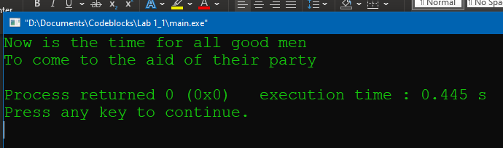

1.2

Exercise 1

#include <iostream>

using namespace std;

int main()

{

int number;

float total;

cout <<"Today is a great day for LAb"

cout <<endl <<"Let's start off by typing a number of your choice" end1;

cin >>number;

total=number*2;

cout <<total << " is twice the number you typed << endl;"

return 0;

}

Exercise 2:

(Compiler error)

**-------------- Build: Debug in Semiprob\ (compiler: GNU GCC Compiler)---------------**

g++.exe -Wall -fexceptions -g -c D:\Documents\Codeblocks\.cbp\Semiprob\main.cpp -o obj\Debug\main.o

g++.exe -o bin\Debug\Semiprob\.exe.exe obj\Debug\main.o

D:\Documents\Codeblocks\.cbp\Semiprob\main.cpp: In function 'int main()':

D:\Documents\Codeblocks\.cbp\Semiprob\main.cpp:10:42: error: expected ';' before 'cout'

10 | cout <<"Today is a great day for LAb"

| ^

| ;

11 | cout <<endl <<"Let's start off by typing a number of your choice" end1;

| ~~~~

D:\Documents\Codeblocks\.cbp\Semiprob\main.cpp:15:62: error: expected ';' before 'return'

15 | cout <<total << " is twice the number you typed << endl;"

| ^

| ;

16 |

17 | return 0;

| ~~~~~~

**Process terminated with status 1 (0 minute(s), 0 second(s))**

**2 error(s), 0 warning(s) (0 minute(s), 0 second(s))**

Successful Compile

g++.exe -Wall -fexceptions -O2 -c D:\Documents\Codeblocks\.cbp\Semiprob\main.cpp -o obj\Release\main.o

g++.exe -o bin\Release\Semiprob\.exe.exe obj\Release\main.o -s

Output file is bin\Release\Semiprob\.exe.exe with size 22.00 KB

*Process terminated with status 0 (0 minute(s), 0 second(s))*

*0 error(s), 0 warning(s) (0 minute(s), 0 second(s))*

Exercise 3

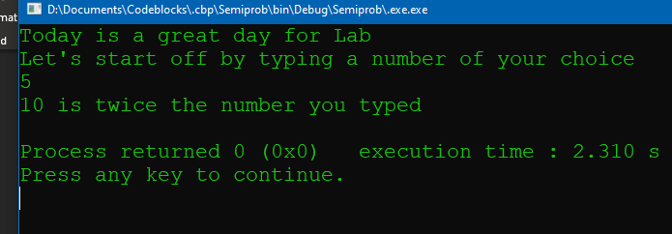

Exercise 4

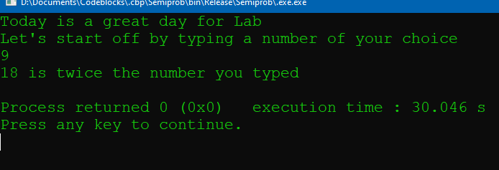

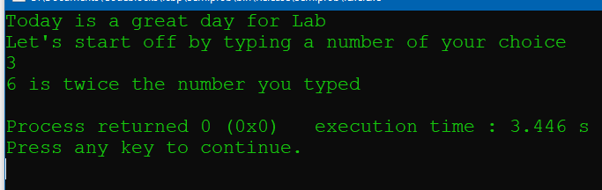

1.3

Exercise 1

#include <iostream>

using namespace std;

int main()

{

float number;

int divider;

divider=0; ******* error

cout <<"Hi there" <<endl;

cout <<"please input a number and then hit return" <<endl;

cin >>number;

number=number/divider;

cout << "Half of your number is " number << endl;

return 0;

}

Exercise 2

Runtime errors because division ny 0

**-------------- Build: Release in Runprob (compiler: GNU GCC Compiler)---------------**

g++.exe -Wall -fexceptions -O2 -c D:\Documents\Codeblocks\Runprob\main.cpp -o obj\Release\main.o

g++.exe -o bin\Release\Runprob.exe obj\Release\main.o -s

D:\Documents\Codeblocks\Runprob\main.cpp: In function 'int main()':

D:\Documents\Codeblocks\Runprob\main.cpp:18:38: error: expected ';' before 'number'

18 | cout << "Half of your number is " number << endl;

| ^~~~~~~

| ;

**Process terminated with status 1 (0 minute(s), 0 second(s))**

**1 error(s), 0 warning(s) (0 minute(s), 0 second(s))**

Exercise 3

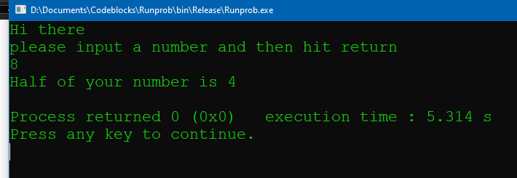

Exercise 4

(messing with data types)

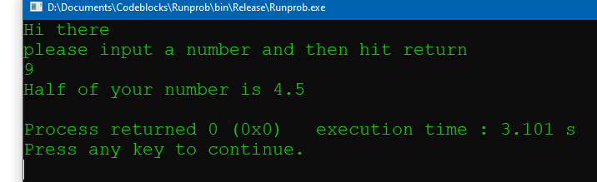

1.4

Exercise 1

//This program takes two values from the user and then swaps them

//before printing the values.The user will be prompted to enter

//both numbers

//Place your name here

#include <iostream>

using namespace std;

int main()

{

float firstNumber;

float secondNumber;

//Prompt user to enter the first number

cout<<"Enter the first number"<<endl;

cout<<"Then hit enter"<<endl;

cin>>firstNumber;

//Prompt user to enter the second number.

cout<<"Enter the second number"<<endl;

cout<<"Then hit enter"<<endl;

cin>>secondNumber;

//Echo print the input.

cout<<endl<<"You input the numbers as "<<firstNumber

<<" and "<<secondNumber<<endl;

//Now we will swap the values.

firstNumber=secondNumber;

secondNumber=firstNumber;

//Output the values.

cout<<"After swapping,the values of the two numbers are "

<<firstNumber<<" and "<<secondNumber<<endl;

return 0;

}

Exercise 2

**-------------- Build: Release in logicprob (compiler: GNU GCC Compiler)---------------**

Target is up to date.

Nothing to be done (all items are up-to-date).

Exercise 3

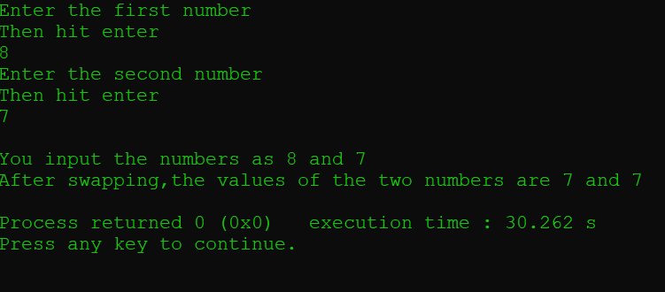

Exercise 4

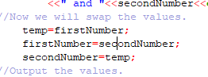

Solution

1.5 challenge

Exercise 1

#include <iostream>

using namespace std;

int main()

{

float number;

cout <<"Please enter the amount of kilometers traveled" <<endl;

cin >>number;

//get input

number*=0.621;

//multiply

cout << "The amount of miles traveled is "<<number << endl;

return 0;

//done

}

Exercise 2

No compiler errors

Exercise 3

